

**DILLA UNIVERSITY**

College of Engineering and Technology

Department of Computer Science

Duration: -July – September 2024

Internship Adviser: - Mr. Gezahegn

Practical supervisors: - Miss. Hiwote and

* Mr. Haileyesus

Hosting company:- Dilla University Information Communication Technology (DUICT)

Submitted by :– Kaleb Menbere

ID Number :- RNS-7209/21

Submission date: -October – 03 – 2024 GC

ACKNOWLEDGEMENT

Any accomplishment requires the blessing of the God. So my first thanks goes to God. I also thanks my adviser Mr. Gezahegn and from hosting company (Dilla University Information Communication Technology (DUICT)) Miss. Hiwote, Mr. Haileyesus and Mr. Beqele for their continuous comments in every steps of the practice work that they forwards throughout the Internship. There are also many people at the company who have helped me in my internship time by sharing their valuable experience.

Finally, a big thank to my family for their encouragement, patience and support throughout my internship time and my entire life.

EXECUTIVE SUMMARY

Internship program is the best thing for students to change their theoretical knowledge that get from class by different course into practical knowledge and to faces the real world situation before taking a serious commitment.

This internship uses to minimize company’s cost used to Train workers after they graduated and employed. It also helps students to develop different skill like practical, interpersonal communication, entrepreneur, and leadership skills.

During my internship period in DUICT, for a period of two months (from July 2024 to September 2024.I have adapted a lot of social interaction with all Coworkers of the company and identified problems and discussed on the solutions and also I have participated in Agro-business idea competition within the University of Dilla Beside to the DUICT company. My report is categorized on chapters, starting from the first chapter which is focus on the brief history of the DUICT, vision, mission, objective, main product, main customer and over all organization and work flow of the company on next chapter I deal with over all internship experience, overall process description, the challenge I faced and the measure I take to overcome the challenge. The next chapter focuses on over all benefit I gained from the internship in terms of upgrading theoretical knowledge, interpersonal communication skill, team playing skill, leadership skill. Other chapters focus on over all achievement and problem-solving project and also I try to give conclusion and recommendation.

Table of Contents

CHAPTER ONE: INTRODUCTION 1

1.1 Profile of Organization 1

1.1.1 Background of The Company 1

1.1.2 Mission of The Company 1

1.1.3 Objectives of The Company 1

1.1.4 Structure of The Organization 2

1.2 Activities of The Organization Related to CS 2

CHAPTER TWO: STUDENTS EXPERIENCE IN INTERNSHIP 4

2.1 Teams and Work Relations among Team Members/Other Staff 4

2.2 Knowledge and Skills Gained 5

2.3 University Taught Programs and the Internship Relatedness 6

2.4 Challenges Faced and How Managed 7

CHAPTER THREE: SWOT ANALYSIS 8

3.1 Strengths 8

3.2 Weaknesses 8

3.3 Opportunities 8

3.4 Threats 9

CHAPTER FOUR: SYSTEM REQUIREMENT AND DESIGN 9

4.1 Introduction 10

4.2 Functional Requirements 11

4.3 Actors 11

4.4 System Design 12

CHAPTER FIVE: CONCLUSION AND RECOMENDATION 24

5.1 Conclusion 24

5.2 Recommendation 25

5.2.1 Recommendation to the hosting company 25

5.2.2 Recommendation to the university 25

REFERENCES 26

List of Figures

Figure 1: structure of the organization 2

Figure 2 : Use Case Diagram of Help Desk System. 12

Figure 3: Homepage of the Help Desk website 13

Figure 4: Login page 13

Figure 5 : Sign Up page 14

Figure 6 :Client Logging in 15

Figure 7 : Client creating new request 15

Figure 8 :Client after creating new request 16

Figure 9: Client request after created 16

Figure 10: ICT Director after logging in. 17

Figure 11: ICT Director approving and assigning team leader. 17

Figure 12: ICT Director after Approving and assigning team leader for the request 18

Figure 13: Request list after Client request Approved and assigned a team leader. 18

Figure 14: Team Leader logging in to see request and assign staff. 19

Figure 15: Team Leader assigning staff member so staff member can fix or check the requested issue 19

Figure 16 : Team Leader after assigning staff member to the requested issue by Client 20

Figure 17 : Staff member logging in to see task assigned to him and make as completed the work he have done. 20

Figure 18: Staff member making the requested issue as completed and fixed 21

Figure 19: Staff after making the request completed and fixed 21

Figure 20 : Client logging in to give feedback on the request he issued. 22

Figure 21: Client after seeing the request that has been made completed and fixed if the problem is fixed, client will give feedback on the matter. 22

Figure 22: Client after giving feedback. 23

Figure 23: Client request list after giving feedback 23

# CHAPTER ONE: INTRODUCTION

## Profile of Organization

In this part we will be seeing the background of my internship hosting company, including: Its brief history, Its main products or services, Its main customers or the end users of its products or services, Its overall organization and work flow.

### Background of The Company

Dilla University is the 1996’s Dilla College of Teachers’ Education and Health Sciences with Faculty of Teachers’ Education and Faculty of Health Sciences. However, in 2001, the College was included in the newly emerging University Debub University. In 2004 Dilla College once again went through another phase and sprung in to a full- fledged University by the councils of minister’s regulation No- 129/04. ICT center of Dilla University was established in 2006 as a computer center, by deploying dial up connection, out-reaching management offices. Lack of professionals characterizes the center, where instructors from mathematics and physics departments were assigned to manage and coordinate the office. It was later in 2007 that an optical fiber installation was activated, exploring almost all the buildings of the time. Despite the launched developments, its functionality and perpetuity was obstructed for lack of documentation to refer, and the temporary instability due to institutional partitioning from the Dilla University. Ever since its establishment, the center has been working closely with different sections of the university to create awareness of ICT, giving training for some staff members of the University, and most importantly to expand network and Internet facilities for the University community. The office is currently established as an ICT Directorate office level with one director five team leaders, 21 professionals and 8 technical supportive staffs.

### Mission of The Company

Develop high-tech ICT infrastructure and provide superior quality services whereby the teaching, learning, research, and administrative activities of the university are carried out by utilizing the resources and services efficiently and effectively.

### Objectives of The Company

* Ensure that ICT is fully integrated into every operations of the University in order to speed up and improve quality of activities of Dilla University.
* DU ICT obligations will be executed with commitment and professionalism.
* DU ICT will maintain a sense of self respect, discipline, and responsibility.
* DU ICT commits them to the practice of teamwork.
* DU ICT embraces efficacy and excellence.

### Structure of The Organization

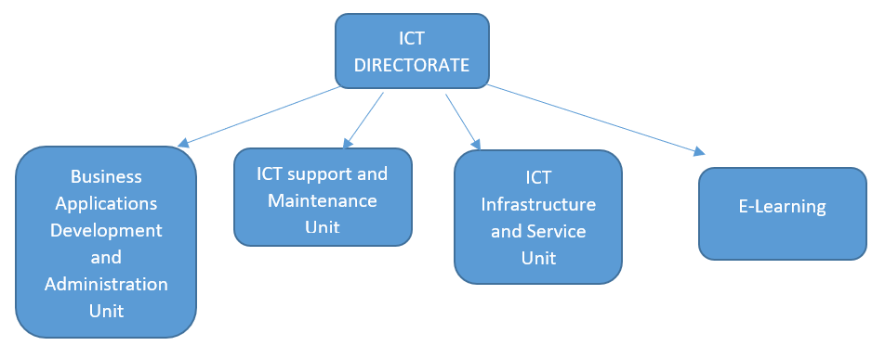

Figure 1: structure of the organization

## Activities of The Organization Related to CS

* Publishing and maintaining the university's website.
* Developing important applications for the University.
* Providing internet service for the university staff.
* Providing ICT support in cases of seminars, workshops and other events.
* Maintenance work for all the computers, printers and some other related electronic tools in the university.
* Protecting computers in the university from various computer security threats.
* Providing ICT related training and consultancy.
* Facilitating teaching and learning technologies.
* Establishing computer laboratories and providing support.
* Facilitating the delivery of the ICT and other computer courses.
* Providing assistance in the purchase of computers and other related electronic tools.
* The DU ICT office strives to provide quality information and communication service to the university's community. Always there is a growing demand towards quality ICT facility. Moreover, each day brings its own challenge and dangers towards the safe way of communication on the internet. It is the office's ultimate objective to strive to enhance the quality of the service and maintain the already existing service intact.

# CHAPTER TWO: STUDENTS EXPERIENCE IN INTERNSHIP

I joined DUICT for my internship during a period when I was actively engaged in a comprehensive training program focused on entrepreneurship and business development. This training was designed to equip us with the skills necessary to leverage our educational background to identify pressing problems in our communities and devise effective solutions. Given that the training required me to stay in Dilla, I embarked on a quest to find a suitable company that offered software development internships. After consulting with the staff at DUICT and some of my teachers, I received valuable recommendations to join DUICT. They assured me that I would receive hands-on training and mentorship, which ultimately motivated my decision to join the organization.

Upon entering DUICT, I specifically requested to be assigned to the Application Development team, as I had a keen interest in software development and wanted to immerse myself in practical, real-world projects. Initially, my role involved observing the workflow within the office. I noted how individuals approached the staff to request support and assistance for various issues. This firsthand observation sparked an idea in me: I decided to develop a web-based application that would facilitate the process of requesting repairs and other assistance. The application was intended to streamline the workflow by allowing users to submit requests, which the ICT Director could then approve and assign to the relevant team leaders for action.

## Teams and Work Relations among Team Members/Other Staff

Throughout my time in the Application Development team, I had the opportunity to engage in a collaborative and dynamic work environment. The team members were supportive and encouraged open communication, fostering a culture of teamwork. Tasks were structured in such a way that everyone was aware of their individual responsibilities while also being encouraged to contribute ideas and solutions collaboratively. I frequently engaged in discussions with my colleagues to clarify project requirements, share progress updates, and troubleshoot any issues that arose. This not only strengthened my communication skills but also enhanced my ability to work effectively within a team setting.

## Knowledge and Skills Gained

Practical Skills

My internship experience significantly enhanced my practical skills, particularly in the following areas:

* Understanding the MVT Concept: Through hands-on experience with Django, I gained a solid understanding of the Model-View-Template (MVT) architecture. This knowledge was crucial in grasping how the various components of a web application interact with one another.
* Working with Django Models: I learned how to create and manage models in Django, which allowed me to understand how data is structured and how to manipulate it using Django's Object-Relational Mapping (ORM) capabilities.
* Using Django Forms: I developed the ability to create and handle forms within Django applications, enabling users to submit their requests easily and interact with the system more effectively.
* Database Management with SQLite: I became adept at managing databases using SQLite, which is Django's default database. I learned to perform migrations, execute queries, and manage data effectively.
* HTML and Django Template Inheritance: My HTML skills improved significantly, and I learned about template inheritance in Django, which allowed me to build efficient, reusable UI components for my web application.

Theoretical Knowledge:

In addition to practical skills, I also upgraded my theoretical knowledge. I learned to identify real-world problems within the organization, such as the inefficiencies in the current support request process. This led me to apply entrepreneurial thinking to create a viable solution—the web-based help desk system that streamlined the process of submitting and managing repair requests.

Interpersonal Communication Skills:

During my internship, I made significant strides in my interpersonal communication skills. I frequently interacted with colleagues, which allowed me to practice conveying information clearly and effectively. I also learned how to explain technical concepts to non-technical staff, which proved essential in ensuring that everyone was on the same page regarding project requirements and progress.

Teamwork Skills:

My experience working in the Application Development team further enhanced my teamwork skills. Collaborating with diverse team members allowed me to understand the value of collective problem-solving and the importance of each member’s contributions to achieving common goals.

Understanding Work Ethics:

Through my internship experience, I gained a deeper understanding of work ethics, particularly the importance of punctuality and accountability. I learned that being reliable and completing tasks on time is crucial in a professional setting, and I made it a priority to adhere to schedules and meet deadlines consistently.

Entrepreneurship Skills:

The training I received alongside my internship helped me cultivate entrepreneurship skills. I became adept at identifying problems and thinking critically about how to address them with innovative solutions, which is a vital aspect of entrepreneurship.

## University Taught Programs and the Internship Relatedness

* Java Programming helped me in the coding process.
* Operating System helped me understand how the computer program work.
* Web Programming show me ways I can code the idea I want.
* C++ Programming (I and II) helped me in the coding process.
* Data Structure and Algorithm helped me understand the logic behind every code.

## Challenges Faced and How Managed

Throughout my internship, I faced several challenges, particularly due to my initial unfamiliarity with the Django framework. I encountered various errors and obstacles that initially hindered my progress. However, I approached these challenges with a positive mindset, viewing them as opportunities for growth. I found it enjoyable to troubleshoot issues and learn from them. I utilized a variety of online resources, such as YouTube from you tubers like mosh telusunki and many more, ChatGPT, Google, Medium, and various blogs to seek solutions and gain insights. This proactive approach not only enhanced my problem-solving skills but also reinforced my commitment to continuous learning.

# CHAPTER THREE: SWOT ANALYSIS

## Strengths

* Strong Institutional Support: DUICT operates within Dilla University, benefiting from support in terms of resources, funding, and strategic alignment with the university's goals.
* Skilled Workforce: The department is staffed with qualified IT professionals and technical staff with expertise in various ICT domains, ensuring high-quality service delivery.
* Established Reputation: DUICT has built a reputation for being a reliable provider of ICT services and solutions within the university, fostering trust among departments.
* Strategic Location: Being on campus allows quick response to issues, enabling fast solutions to IT problems and ensuring the smooth operation of university services.
* Diverse Services: DUICT offers a wide range of services, including network infrastructure, software development, hardware support, and user training, which enhances its versatility.

## Weaknesses

* Limited Budget: As part of a public institution, DUICT may face budget constraints, limiting its ability to upgrade technology, hire more staff, or invest in new projects.
* Dependence on University Policies: DUICT’s operations are tied to university bureaucracies and policies, which can slow down decision-making processes and limit flexibility.
* Lack of Specialized Training: There might be gaps in training, particularly in emerging technologies, limiting the department’s ability to implement the latest innovations.
* Inconsistent Internet Infrastructure: The performance of ICT services is often dependent on the university’s network infrastructure, which may be prone to outages or inconsistencies.

## Opportunities

* Technological Advancements: DUICT can leverage advancements in cloud computing, AI, and automation to enhance the efficiency of its services and reduce manual workloads.
* Digital Transformation: There is a growing push for universities to digitize services. DUICT could capitalize on this trend by offering more innovative digital solutions, such as e-learning platforms and automated administrative services.
* Collaboration with Industry: Partnering with private IT companies or government programs can provide access to additional funding, training, and resources.
* Expansion of Services: The university’s increasing reliance on technology presents opportunities to expand services such as network security, data management, and IT consulting.
* Skilled Interns: Leveraging talented students and interns from the university's ICT programs could help reduce costs and foster innovation in the department.

## Threats

* Technological Obsolescence: The rapid pace of technological change could make DUICT's current infrastructure and systems outdated, requiring costly upgrades.
* Cybersecurity Risks: As the use of digital services expands, the risk of cyberattacks and data breaches also increases, which could compromise sensitive university data.
* Competition for Talent: The ICT industry is highly competitive, and DUICT may face challenges in retaining skilled staff who may leave for better opportunities in the private sector.
* Budget Cuts: External financial pressures, such as government funding reductions or university-wide budget cuts, could impact the department’s ability to maintain service levels.
* Dependence on External Vendors: Reliance on third-party vendors for software and hardware could be a vulnerability if vendors fail to meet expectations or raise prices.

# CHAPTER FOUR: SYSTEM REQUIREMENT AND DESIGN

Project Title: Help Desk System for DUICT

Why this Title: The title "Help Desk System" was chosen because the system aims to simplify and streamline the process of requesting and managing ICT support services within Dilla University. The current manual system, which involves paperwork and in-person visits to the ICT office, is inefficient and often leads to delays and confusion. This system will digitize the process, making it easier for departments to request assistance and for the ICT team to manage and track requests.

Stakeholders (Actors):

* ICT Director: Oversees the entire process and assigns requests to appropriate team leaders.
* Team Leaders: Assign specific tasks to staff members and ensure timely resolution.
* Staff: Handle technical issues and report on their status.
* Clients (Departments and Offices): Submit requests for ICT services.

Programming Tools:

* Backend: Django (Python) for managing data, workflows, and user roles.
* Frontend: HTML, Bootstrap, and CSS for designing the user interface.

Basic Functionalities:

* Users (clients) can submit service requests online.
* Requests are forwarded to the ICT Director for approval and assignment.
* The Director assigns tasks to the appropriate team leader.
* Team leaders allocate tasks to staff members.
* Staff members resolve issues and provide status updates.
* Clients can confirm whether the problem is resolved.

## Introduction

Our project Title is Help Desk and It’s main objective is to simplify the process of requesting any support through this website and get the service

We selected this title because during in our internship program we noticed that Dilla University employees who works in the department office and directories office fill out paper forms and come to the DUICT and are confused where they would go and ask for the service they require and they often are told to go to this office and that office, it is really frustrating, so we came up with an idea of website which accepts requests that they need and directly send to the ICT director to assign the correct team to the task.

The tools that are used to develop the website is Django in the back-end and HTML and Bootstrap & CSS in the front-end.

The project will develop a web-based application accessible to all departments and directories office within Dilla University. It will include form for submitting requests, approval workflows, team leader assignment, checking if the task is completed or not and give feedback.

The limitation of the project is that it relies on the availability of internet and network infrastructure within the university. Additionally, training will be required to ensure all users can effectively use the system.

## Functional Requirements

1. Service will be requested by clients/customers

2. Customers/clients shall be registered

3. Customer request will be directed to ICT director

4. Director shall redirect the request to any of the team leaders

5. Team leader shall assign a staff(professional) to fix the particular request(problem)

6. The staff shall report the problem is solved or not

7. The customer shall flag acknowledgment if problem fixed or issue handled

## Actors

I. ICT director

Ii. 4 different Team leaders

Iii. Staff

Iv. Client (Department and Directories office)

## System Design

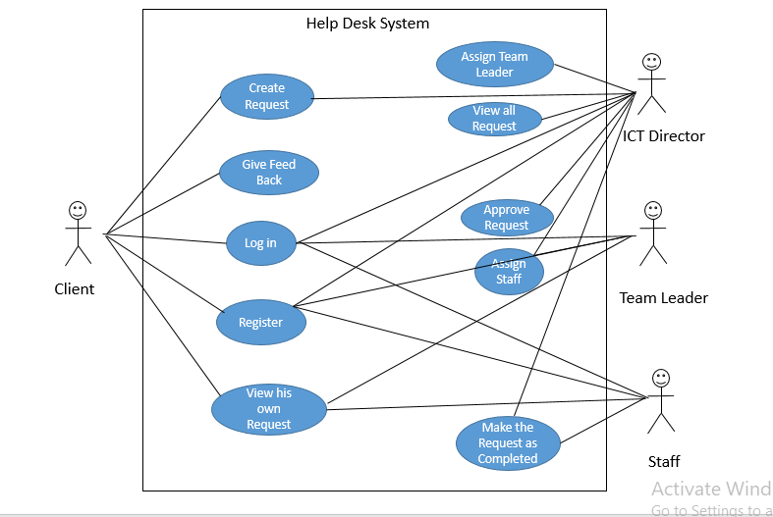

Figure 2 : Use Case Diagram of Help Desk System.

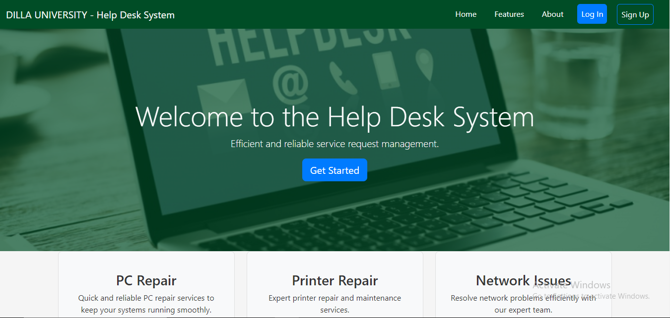

Figure 3: Homepage of the Help Desk website

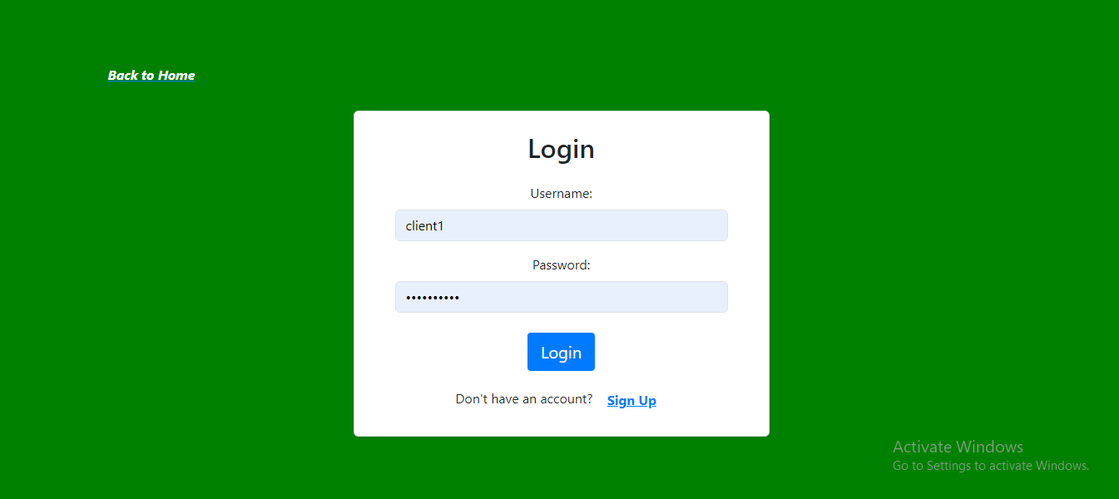

Figure 4: Login page

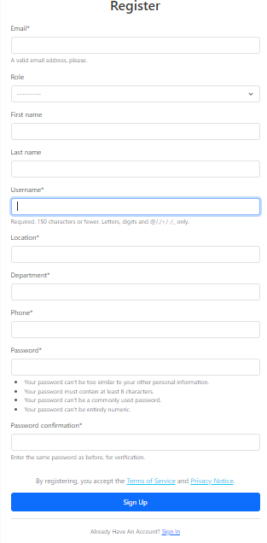

Figure 5 : Sign Up page

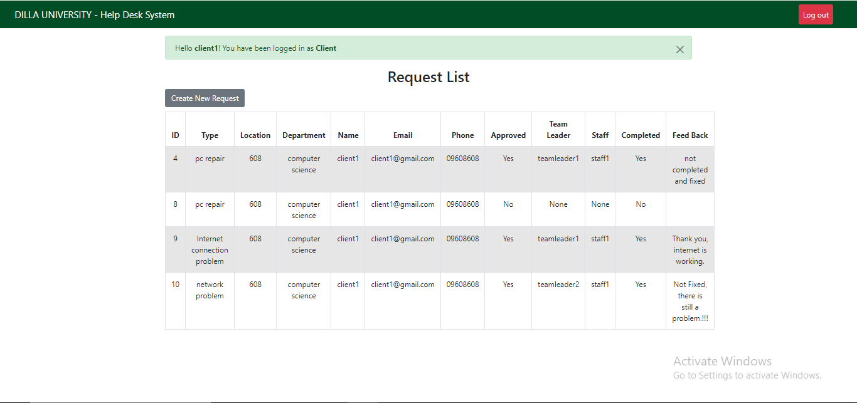

Figure 6 :Client Logging in

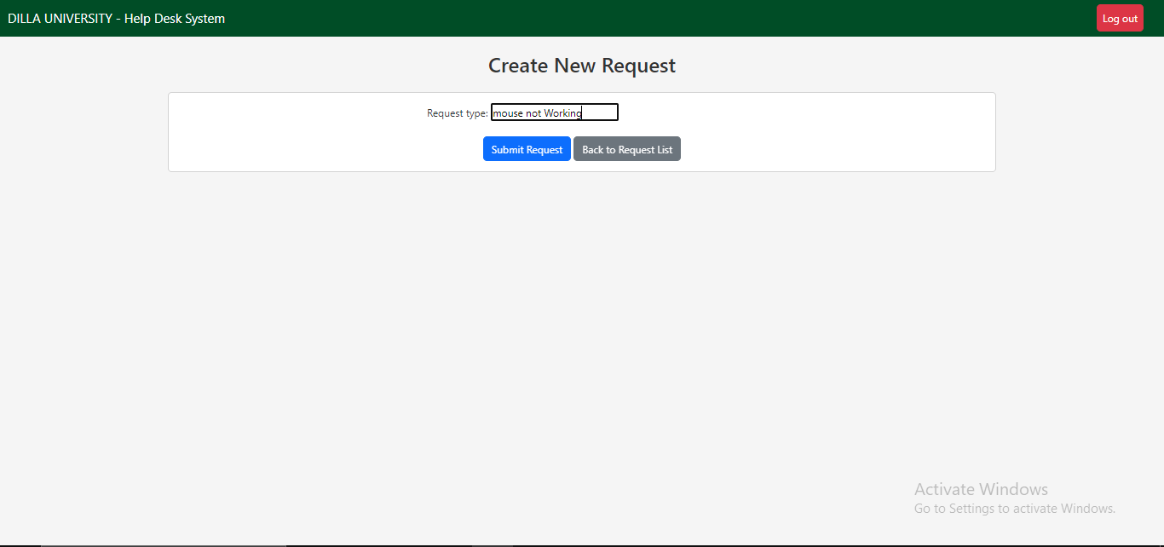

Figure 7 : Client creating new request

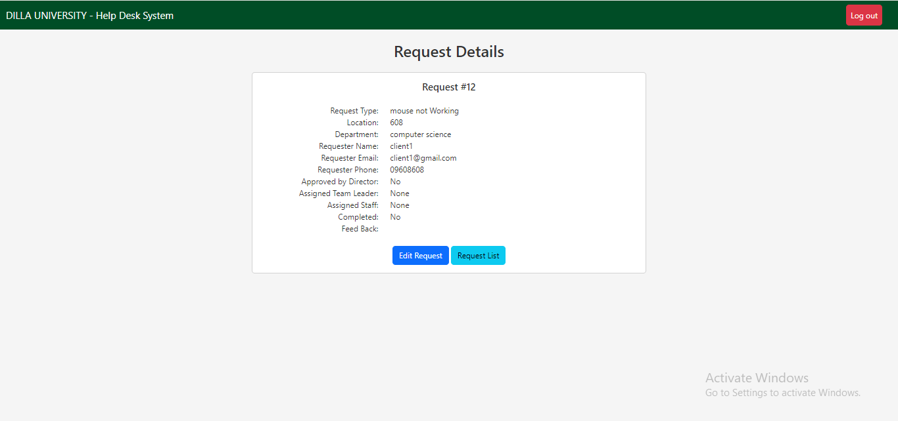

Figure 8 :Client after creating new request

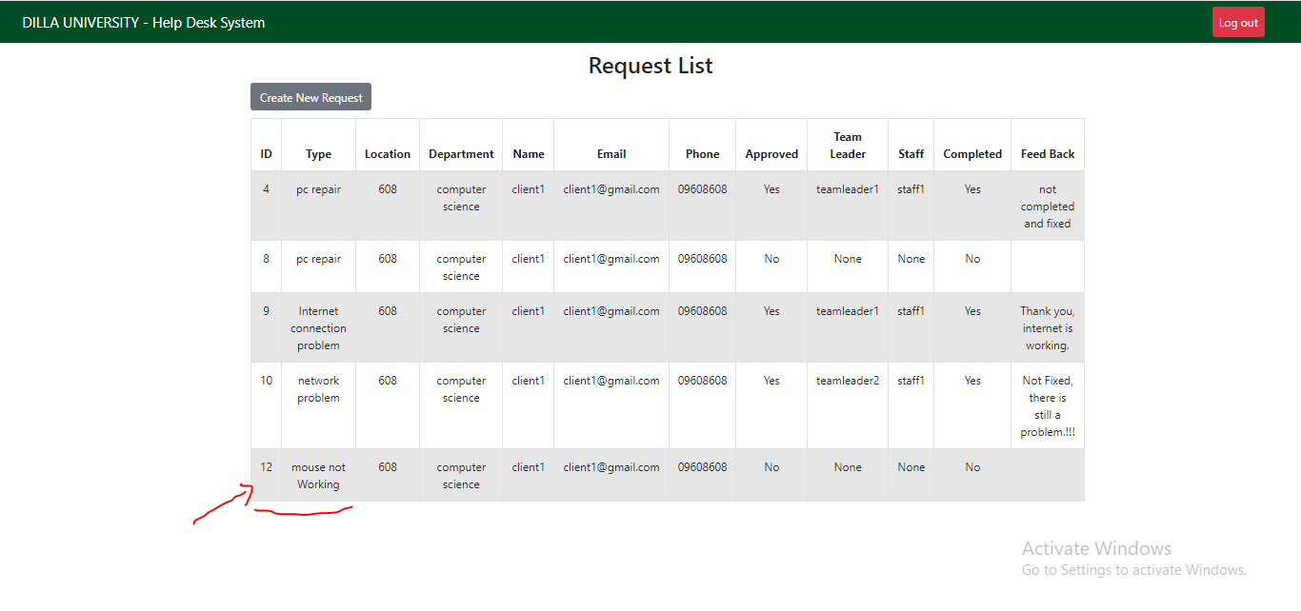

Figure 9: Client request after created

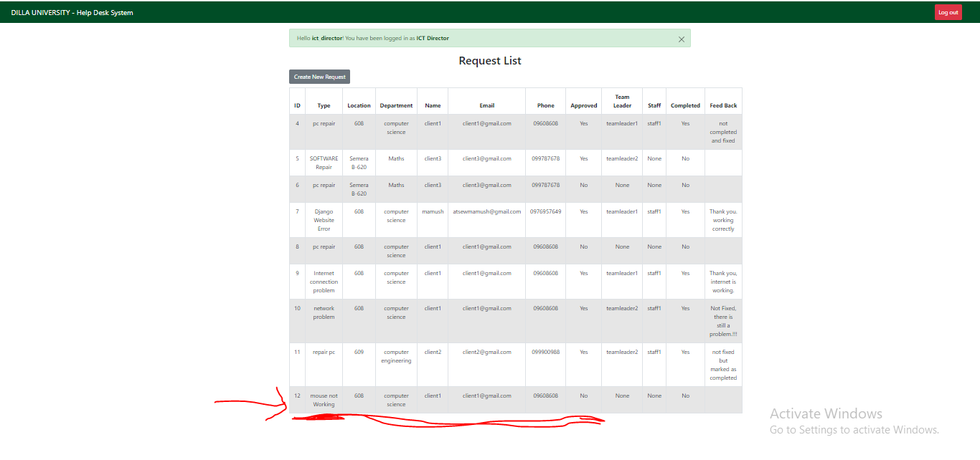

Figure 10: ICT Director after logging in.

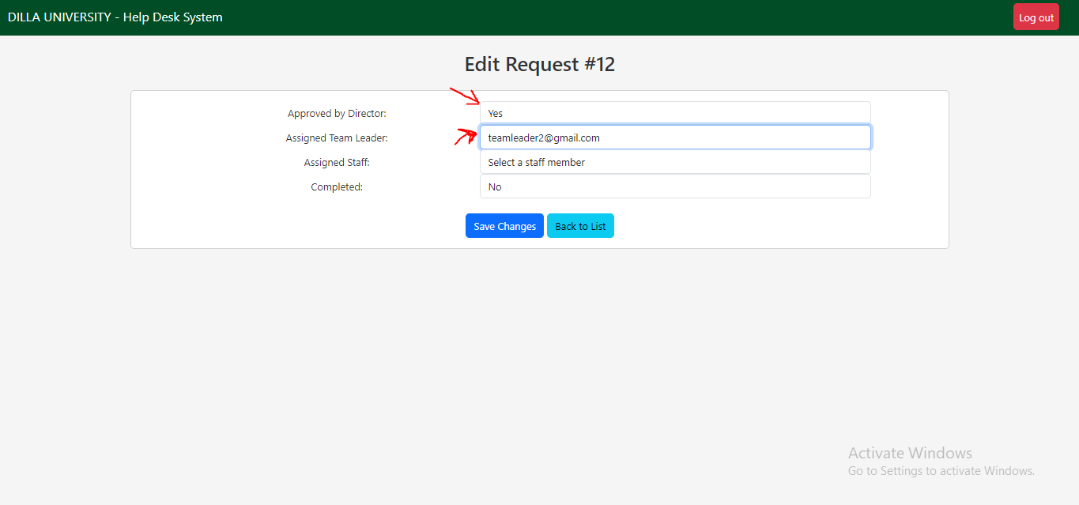

Figure 11: ICT Director approving and assigning team leader.

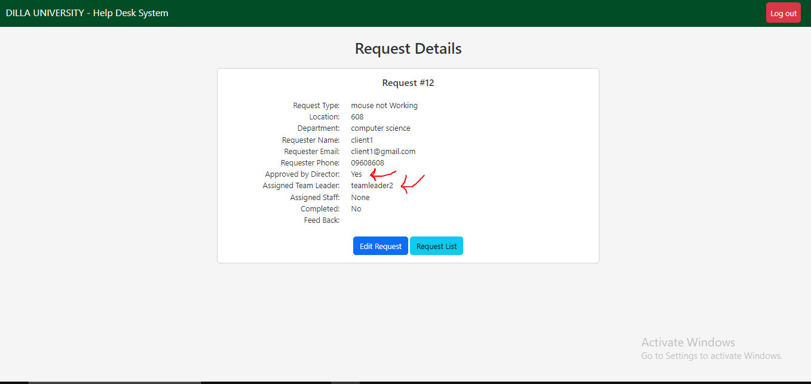

Figure 12: ICT Director after Approving and assigning team leader for the request

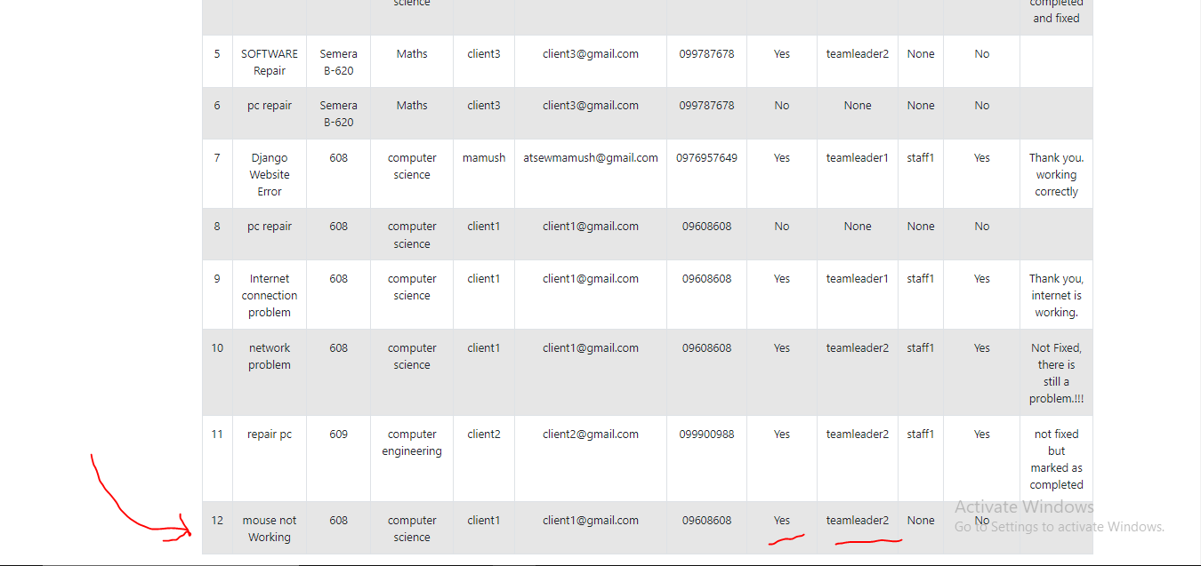

Figure 13: Request list after Client request Approved and assigned a team leader.

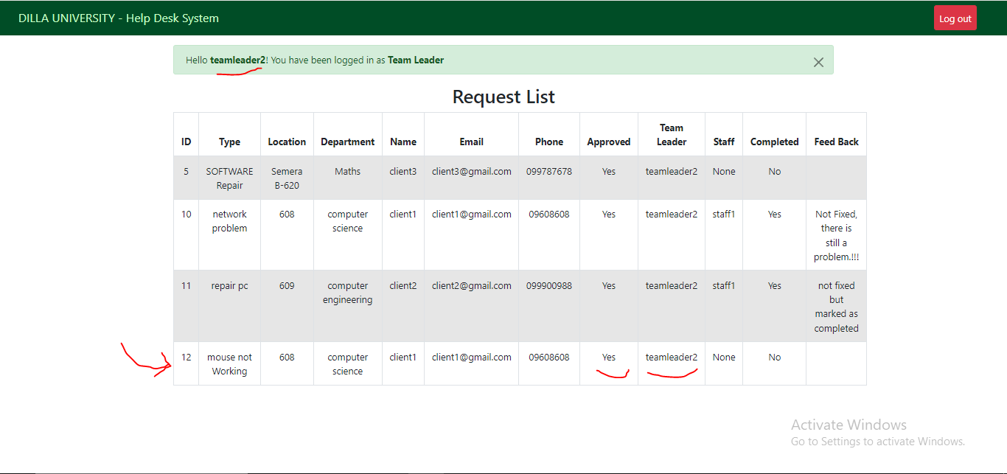

Figure 14: Team Leader logging in to see request and assign staff.

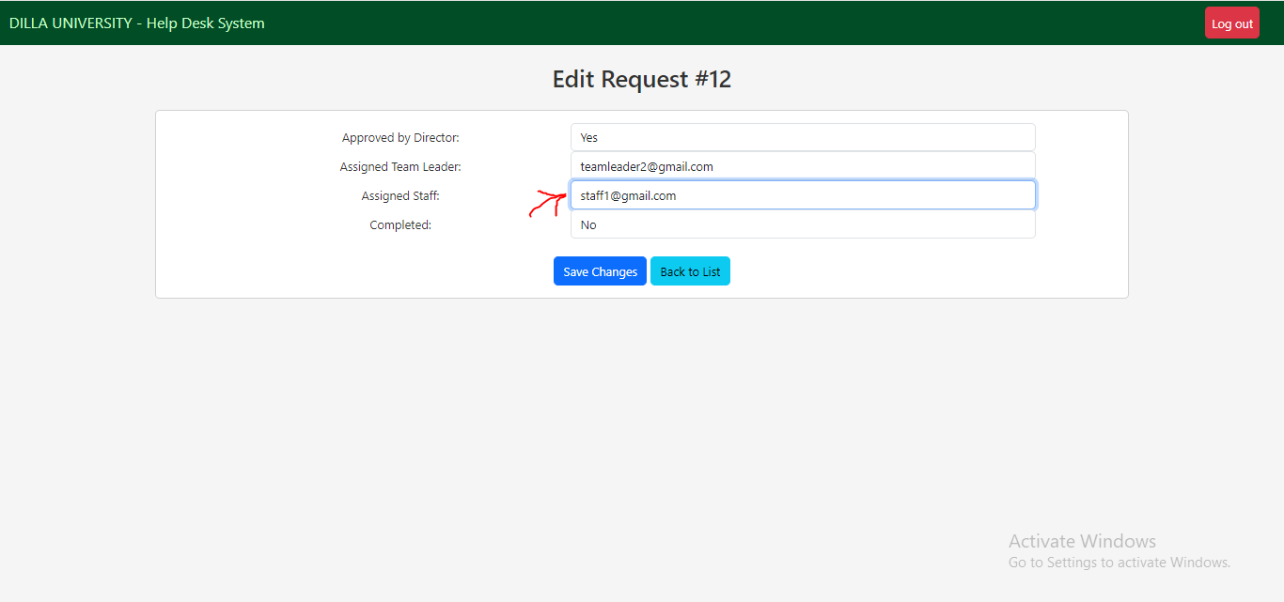

Figure 15: Team Leader assigning staff member so staff member can fix or check the requested issue

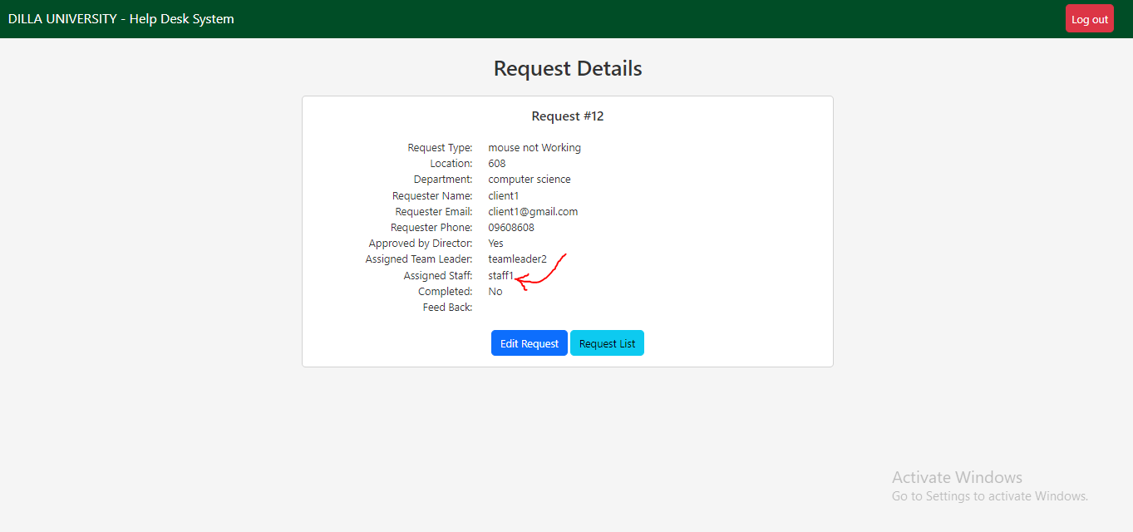

Figure 16 : Team Leader after assigning staff member to the requested issue by Client

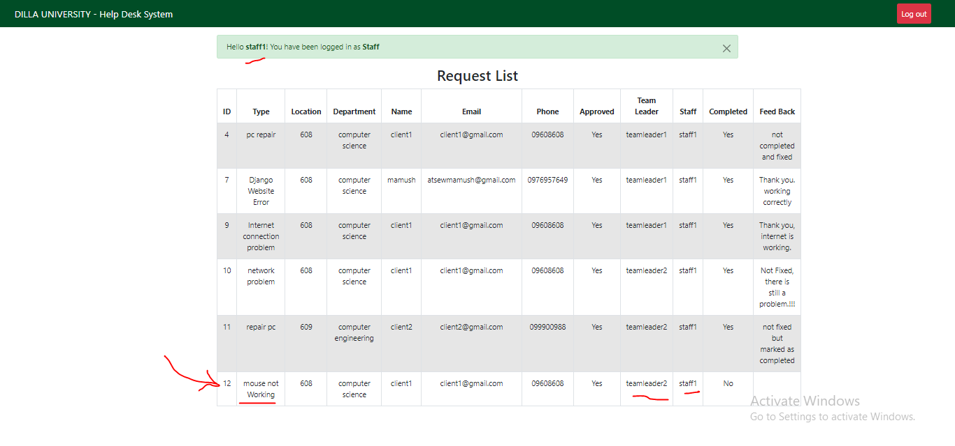

Figure 17 : Staff member logging in to see task assigned to him and make as completed the work he have done.

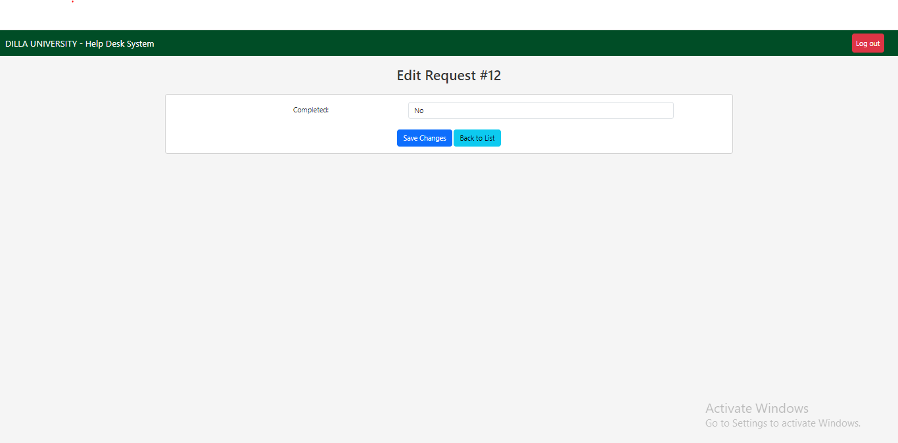

Figure 18: Staff member making the requested issue as completed and fixed

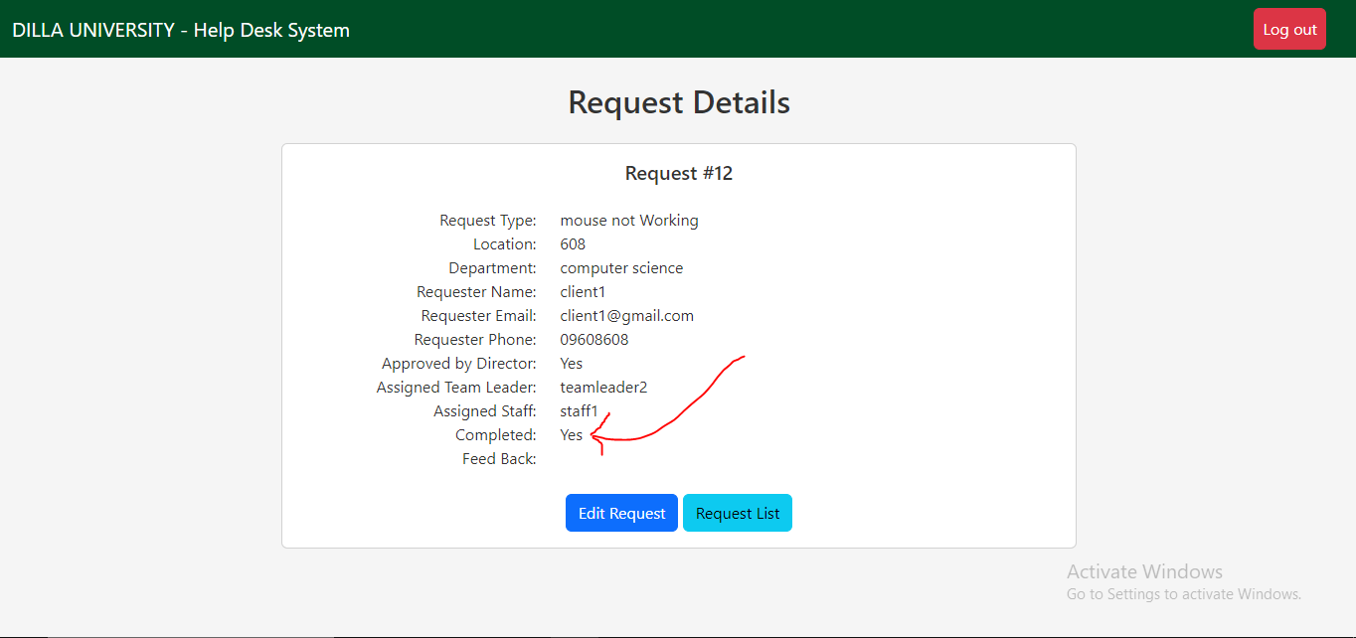

Figure 19: Staff after making the request completed and fixed

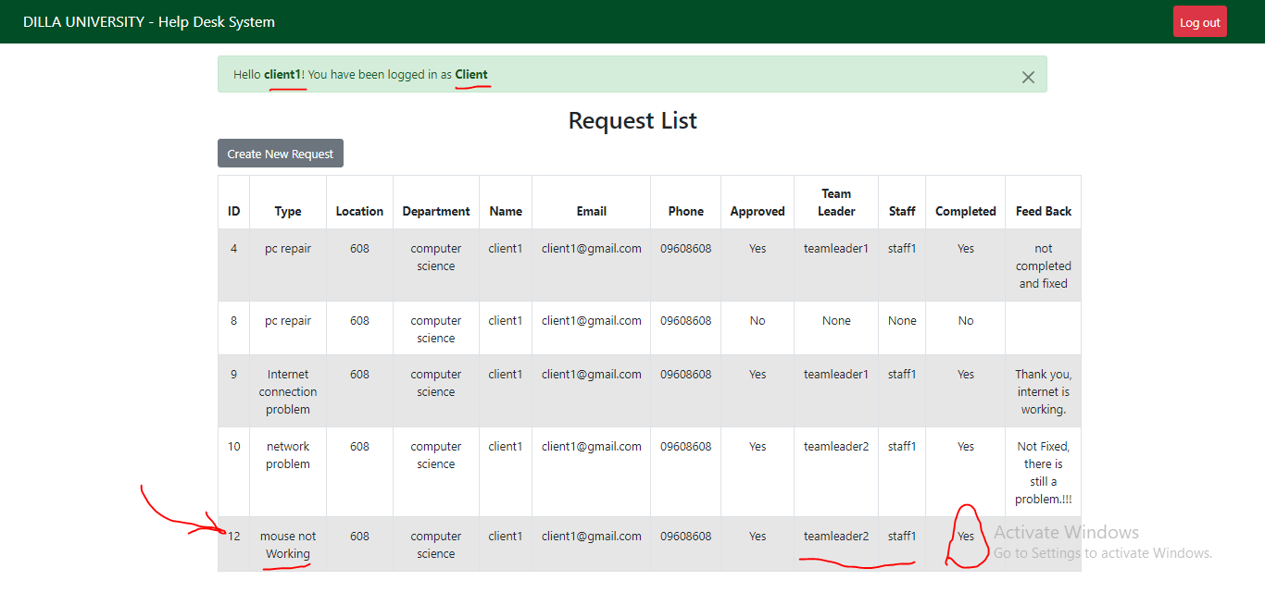

Figure 20 : Client logging in to give feedback on the request he issued.

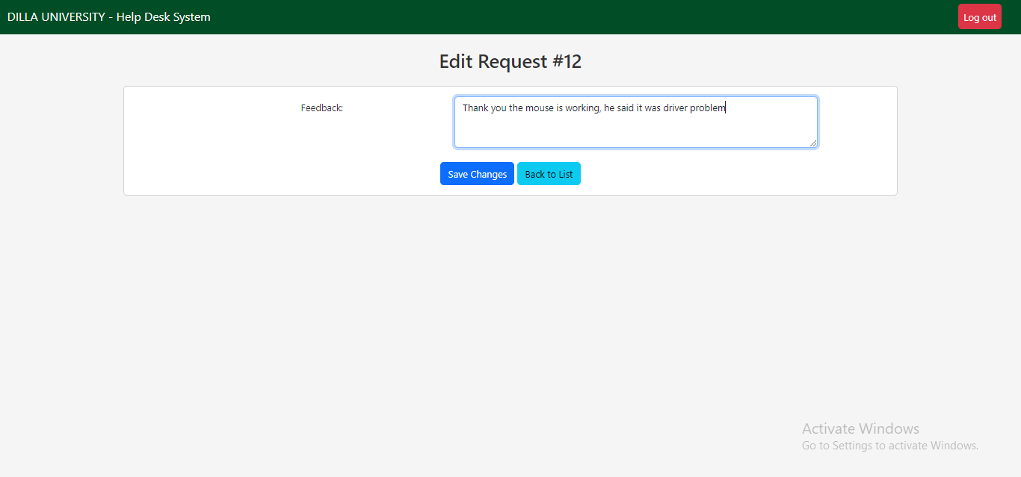

Figure 21: Client after seeing the request that has been made completed and fixed if the problem is fixed, client will give feedback on the matter.

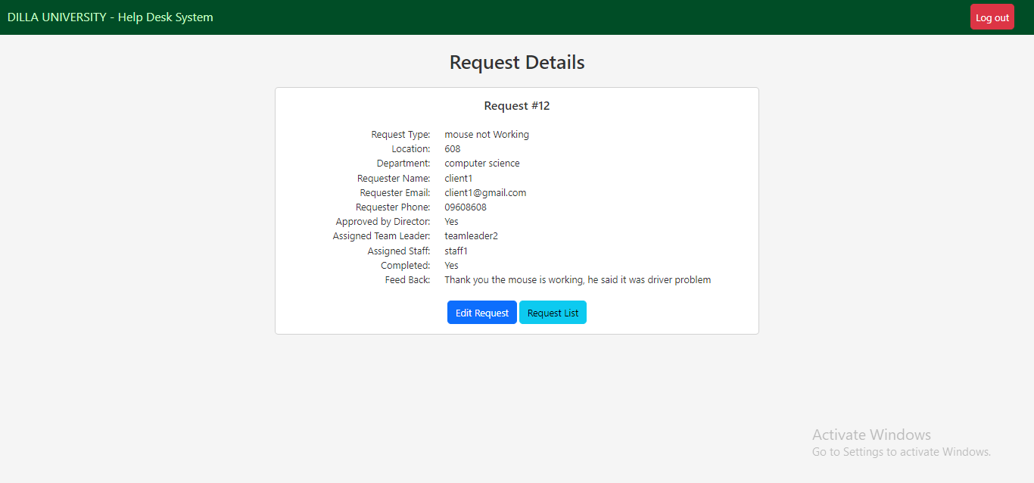

Figure 22: Client after giving feedback.



Figure 23: Client request list after giving feedback

# CHAPTER FIVE: CONCLUSION AND RECOMENDATION

## Conclusion

The internship program is the best program for university students because I changed the theoretical knowledge in to practical. During the internship period in DUICT networking and computer maintenance, I observe different types of computer programming knowing MVT and other programming methods, framework, libraries and also python the latest programming language. For my two months in internship program, I have concluded that it gives real practical skills and make students being familiar to the outside industries world. Truly, it prepared me to pay special attention in all practical activities that will be carried out in the company. Because, of little error or mistake can leads to large failure in the programming process if it is not carried in the correct procedure. Also this program allows me to make and develop professional contacts for my future time and it helps me to know working standards. Most the theoretical things I have been learned got illustrated here in this program, which develops more my confidence in the theoretical knowledge. Some of the benefits I gained from the internship program are listed below as: -

* I Know how to face the real world
* Know about different programming languages specially the latest one python.
* Team working skill and seeking for help in case of difficulties without any shame.
* Work ethics and Entrepreneurship skill gain.
* Identify different problem occur in the company and give the solution by communicating with the formal and technician of the company.
* Communication skills
* Upgrading my theoretical knowledge
* Team working and leadership skills

## Recommendation

During my internship time I observe different problem standing from my observation as an internship student I would to give some recommendation to my hosting company DUICT and to my university.

### 5.2.1 Recommendation to the hosting company

As a student I would like to give some recommendation to my hosting company DUICT. Some of the recommendations suggested to the company that I have seen for the last two month main problems of a company those are as follows:

* The company do not have full networking materials like electronic resource, I recommend the company that fulfill the material.
* The company should improve the man power educational level and give for them full training capability of the new Programming languages and new technologies.

### 5.2.2 Recommendation to the university

I would like to recommend to my university: The university needs to give special attention to the course that given in the class and upgrading the knowledge of some teachers about that course. As my university mainly concerns about programming it need to have a course about what industries are need and the real world’s activities like the programming languages and other computer systems. The university should arrange some practical visit in some courses before and after the internship program. Because it helps student to easily understand what they learn in their laboratory and lecture class session.

* And also the university has to take the responsibility of placing the students with appropriate companies because it is difficult for the students to communicate with the hosting companies.
* Finally, the budget allocation for this internship program is not enough for the students to in this program.

# REFERENCES

1. <https://www.du.edu.et/>
2. <https://youtu.be/tUqUdu0Sjyc>
3. <https://www.w3schools.com/django/django_intro.php>
4. <https://youtu.be/PtQiiknWUcI>
5. El-Sharoud, W. (2019). Book Review: Charles
6. Severance, Python for everybody.